

1011 West Main Street
Louisville, KY 40202
PHONE: 502-560-1551
FAX: 502-560-1532
tom.delacenserie@kylottery.com
TOM DELACENSERIE
President & CEO

TO: Governor Matt Bevin
President of the Senate Robert Stivers
House Speaker Pro Tempore David Osborne

FROM: Tom Delacenserie, President & CEO

DATE: January 19, 2017

SUBJECT: DECEMBER MONTHLY REPORT

The large Powerball and Mega Millions jackpots resulted in significant sales increases this month. Keno was nearly on point with budget, which was a positive change from the first five months of the fiscal year. Scratch-off sales were up thanks to the holiday game strategy, along with new game launches in December. And, prize payouts continue to trend below budget, resulting in higher gross profits.

The Bob Newhart TV commercial continued from Thanksgiving Day through Christmas Day. Holiday iLottery games launched, and the KLC is moving forward with a multi-price point model for select games for future launches in third quarter.

The KLC produced Facebook Live “Ask Us Anything” broadcast for December, as well as Facebook Live “The Game Show” for the Big Money Monday launch. In addition, over 8000 players entered “The 12 Days of Winning” Facebook promotion.

The entire package of the December financial statements is attached. Below is a brief synopsis of December 2017 compared to prior year and budget.

December 2017 vs. Prior Year and Budget
SALES
 | Amount ('000s) |  | % change vs. Prior Year |  | % change vs. Budget
Total Sales | 91,946 |  | 8.3% |  | 1.6%
Instant Sales | 53,160 |  | 2.5% |  | -3.2%
Draw Sales | 30,920 |  | 18.2% |  | 11.2%
Keno Sales | 6,976 |  | 8.4% |  | -0.6%
iLottery Instant Play Sales | 890 |  | 116.0% |  | 11.8%
EXPENSES
 | Amount ('000s) |  | % change vs. Prior Year |  | % change vs. Budget
Prize Expense | 56,810 |  | 1.7% |  | -1.6%
Overall Prize Payout % | 62.3% |  | -4.5% |  | -2.1%
Operating Expenses | 2,440 |  | -10.6% |  | -12.9%
INCOME/TRANSFERS
 | Amount ('000s) |  | % change vs. Prior Year |  | % change vs. Budget
Income Before Transfer of Dividends | 25,098 |  | 36.4% |  | 13.5%
KLC Transfers (General Fund) | 20,500 |  | 2.5% |  | 0.0%
KEES Reserve Fund (Accrued) | 597 |  | 38.2% |  | -20.4%

Respectfully submitted,

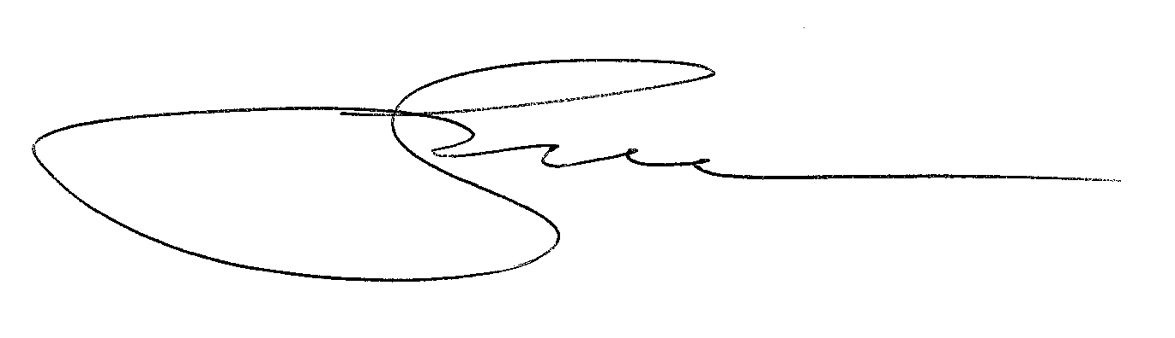
cc: KLC Chairman Sommer
/tmp/in/input.doc

